Insights from literature

**Time on the market and selling price – Miller 1978**

Both variables are influenced by the characteristics of the property (size, location, quality).

In this case study: a longer selling time means a higher selling price, but not significant.

Longer marketing periods do not achieve a higher selling price.

I**nfluential Factors on the Market Value of Residential Properties - Ferlan, Bastic, Psunder 2017**

Location in relation to the distance from the city centre is most important for the property value.

Location of available parking paces was a great impact on the value.

Absence of negative factors for the environment are a positive impact of the value.

Time on the market decreases with the age of a property and increases with its size, although the latter effect seems to diminish and disappear for very large properties

Financial situation --> ability to loan money

Location --> in the centres it takes longer to sell than rural areas

**The economic value of neighborhoods: Predicting real estate prices from the urban environment - Marco De Nadai and Bruno Lepri 2018**

Some of the most important features of properties and surroundings to predict real estate housing prices include the following:

* 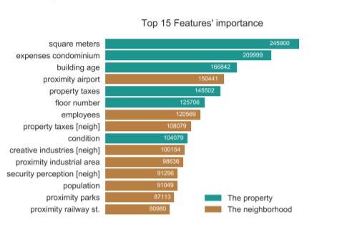Square meters
* Building age
* Proximity of airport
* Proximity industrial area
* Proximity railway station
* Population